Made BY :-Jadeja Mouryrajsinh
1. Introduction

This document describes the design and implementation of an E-Commerce Database System using PostgreSQL on Ubuntu Linux.
The objective of this project is to understand how real-world e-commerce platforms manage users, products, orders, and payments using relational databases and SQL.

This database allows:
- Customers to register
- Products to be stored
- Orders to be placed
- Payments to be recorded
- Sales data to be analyzed

2. Database Creation

Database Name: ecommerce_db
The database was created using PostgreSQL with the following command:
CREATE DATABASE ecommerce_db;
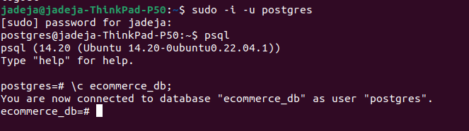
3. Table Creation

The following tables were created to store e-commerce data:
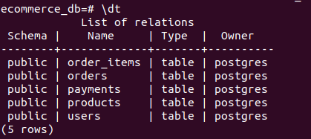

Table Name | Purpose
users | Stores customer details
products | Stores product information
orders | Stores customer orders
order_items | Stores which products are in each order
payments | Stores payment details

These tables were created using SQL with Primary Keys and Foreign Keys to ensure data integrity.

4. Data Insertion

Large realistic data was inserted into all tables:
- More than 90 users
- More than 90 products
- More than 90 orders
- More than 90 order items
- More than 90 payments
The data contains customer names and product and payment information.
Example:
INSERT INTO users (name, email, password)
VALUES ('Amit Patel','amit@gmail.com','123');
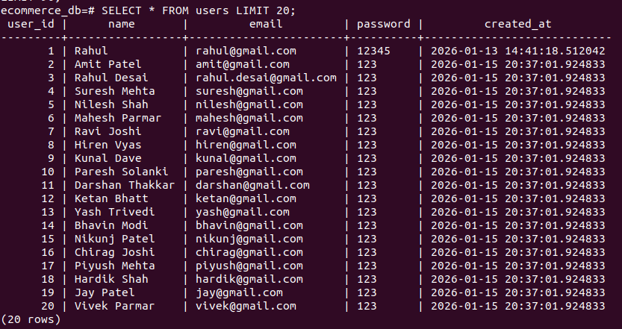
- Users Data:
- Product Data:
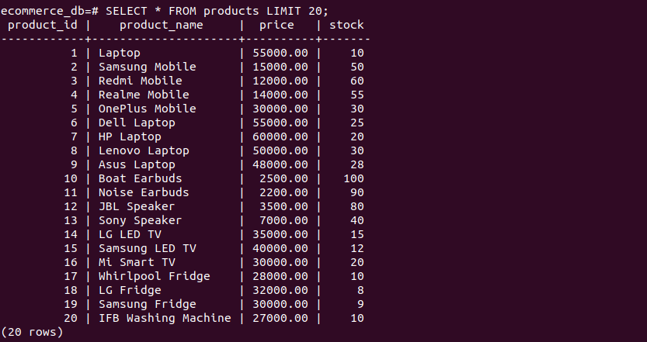
- Order Data:
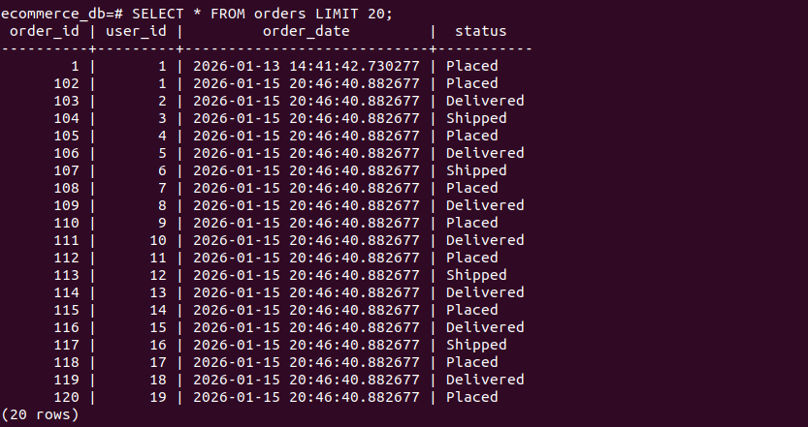

5. Fetching Records (SELECT Queries)
The following SQL queries were used to verify inserted records:
SELECT * FROM users;
SELECT * FROM products;
SELECT * FROM orders;
SELECT * FROM order_items;
SELECT * FROM payments;
Order_item Verify:
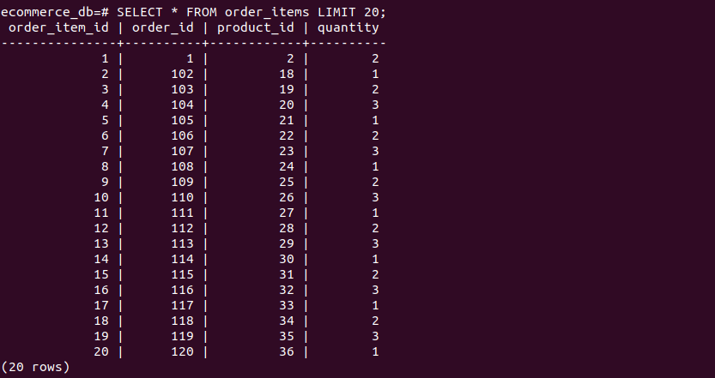

Payments Verify:
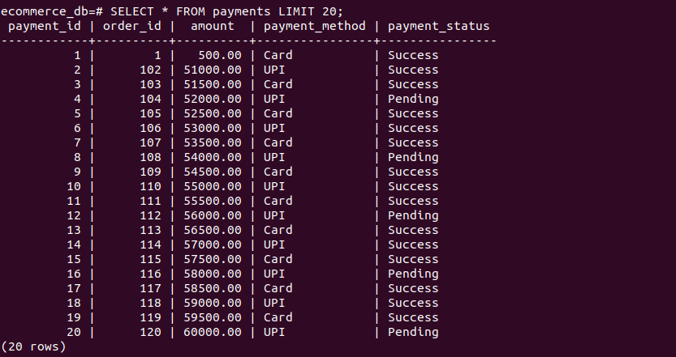

6. Table Relationships
The database follows a real-world relational model:

Relationship | Type
Users → Orders | One-to-Many
Orders → Order_Items | One-to-Many
Products → Order_Items | One-to-Many
Orders → Payments | One-to-One

This allows tracking:
- Which user placed which order
- Which products are in each order
- How much was paid

7. Performing Queries

Filtering Data (WHERE)

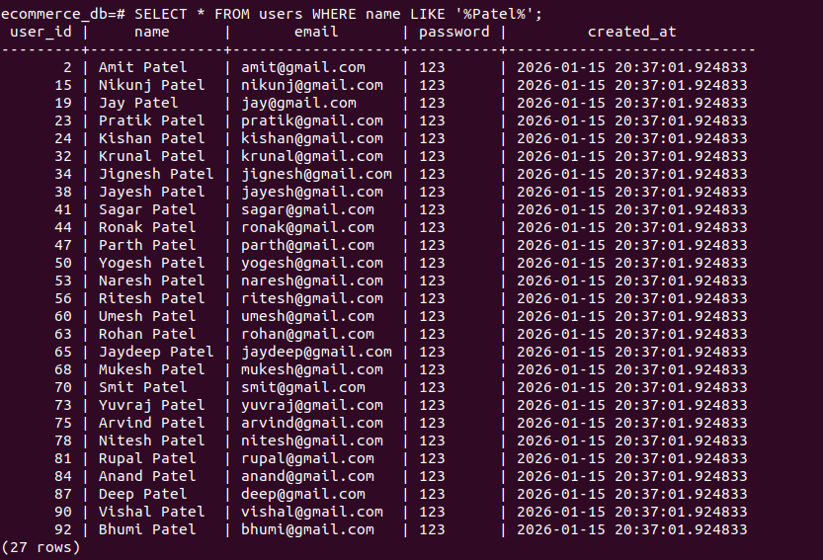
- SELECT * FROM users WHERE name LIKE '%Patel%';

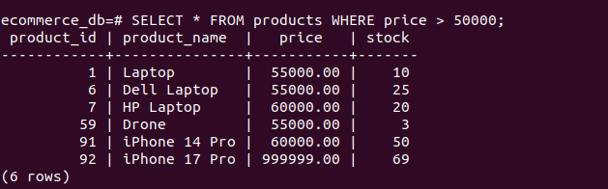
- SELECT * FROM products WHERE price > 50000;

- SELECT * FROM orders WHERE user_id = 10;

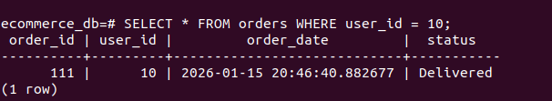

- SELECT * FROM order_items WHERE quantity = 2;
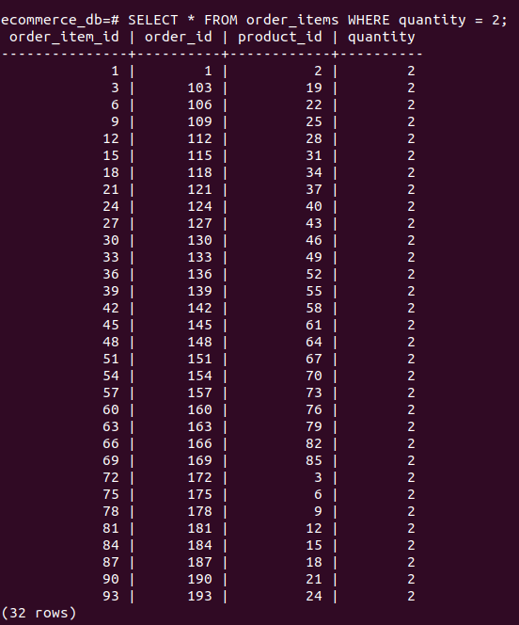

Sorting Data (ORDER BY)

- SELECT * FROM products ORDER BY price DESC;
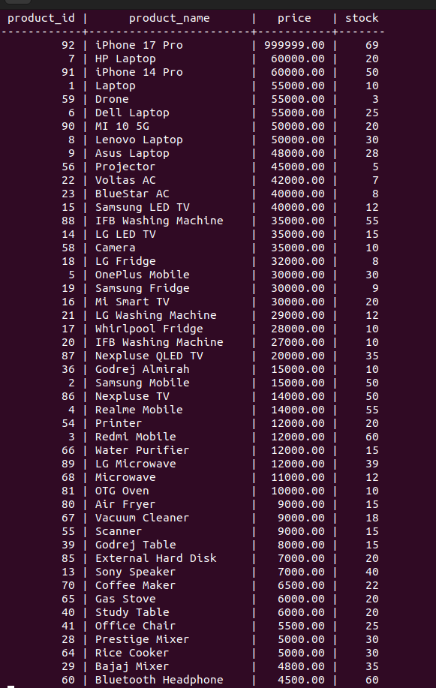

- SELECT * FROM products ORDER BY price ASC;

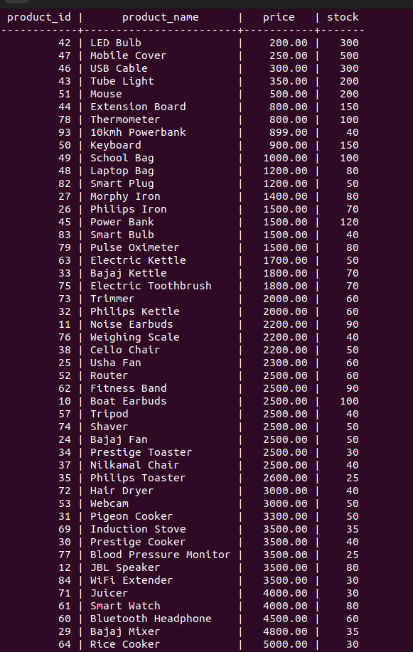

- SELECT * FROM users ORDER BY name;

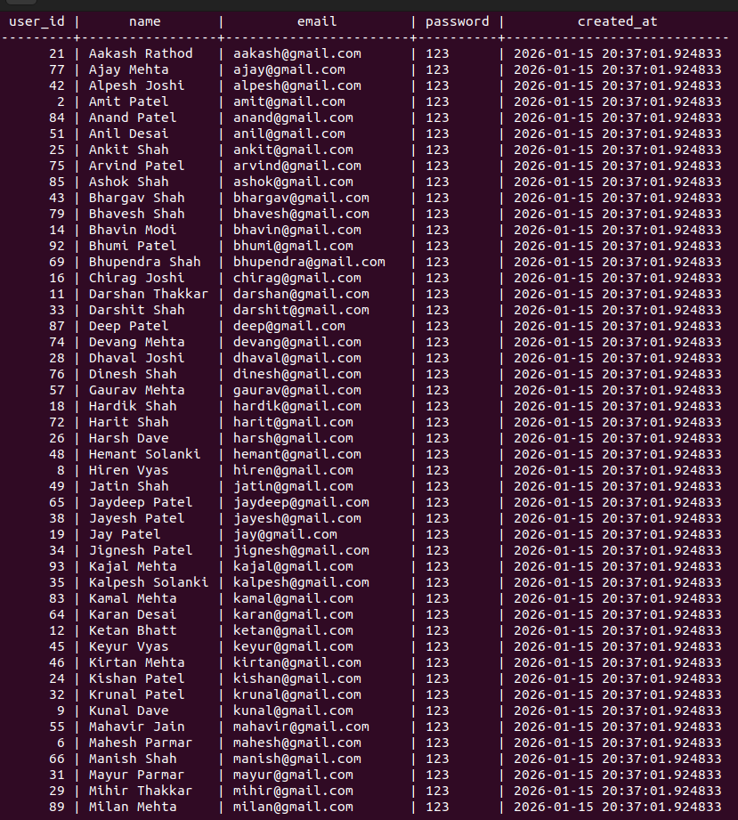

- SELECT * FROM orders ORDER BY order_date DESC;

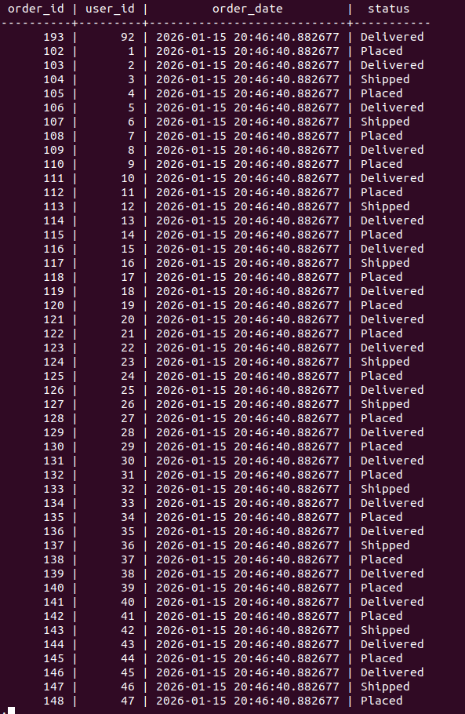

SQL Aggregate Functions

- SELECT COUNT(*) AS total_users FROM users;
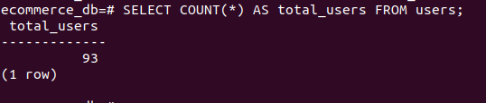

- SELECT COUNT(*) AS total_products FROM products;
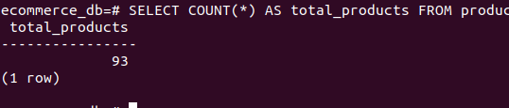

- SELECT MAX(price) AS highest_price FROM products;
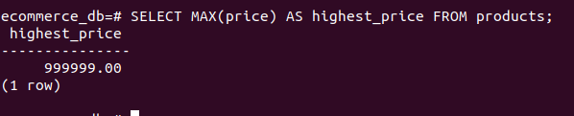

- SELECT MIN(price) AS lowest_price FROM products;
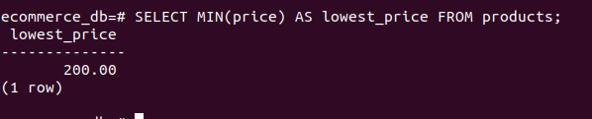

- SELECT AVG(price) AS avg_price FROM products;
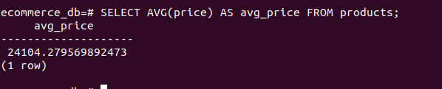

GROUP BY Queries

- SELECT user_id, COUNT(*) AS total_orders FROM orders GROUP BY user_id;

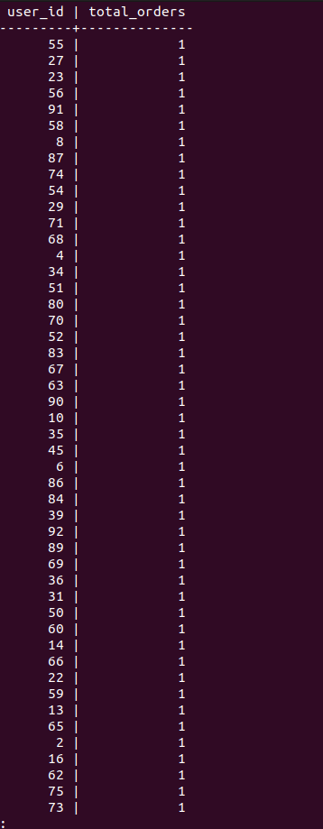

- SELECT product_id, SUM(quantity) AS total_quantity FROM order_items GROUP BY product_id;
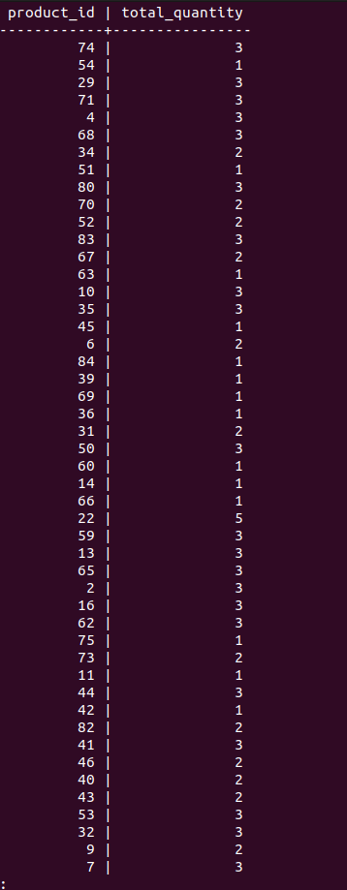

HAVING Clause

- SELECT user_id, COUNT(*) AS order_count FROM orders GROUP BY user_id HAVING COUNT(*) > 1;

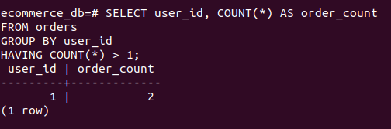

JOIN Queries

INNER JOIN
- SELECT o.order_id, u.name, o.order_date FROM orders o INNER JOIN users u ON o.user_id = u.user_id;
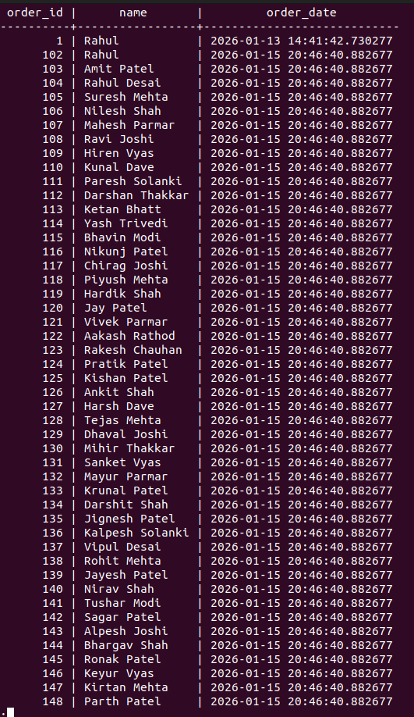

- SELECT p.product_name, oi.quantity FROM order_items oi INNER JOIN products p ON oi.product_id = p.product_id;

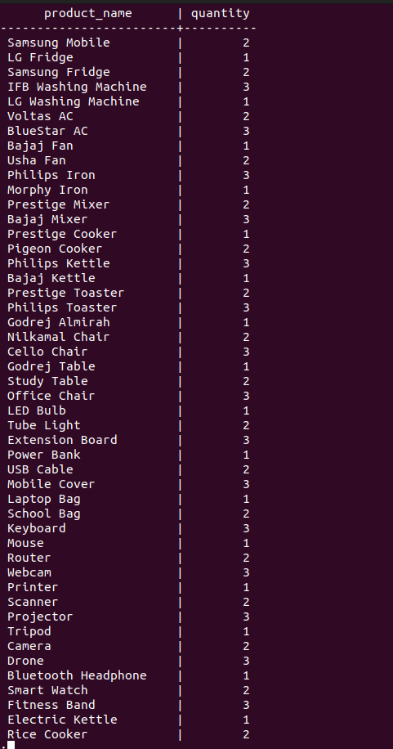

LEFT JOIN
- SELECT u.name, o.order_id FROM users u LEFT JOIN orders o ON u.user_id = o.user_id;

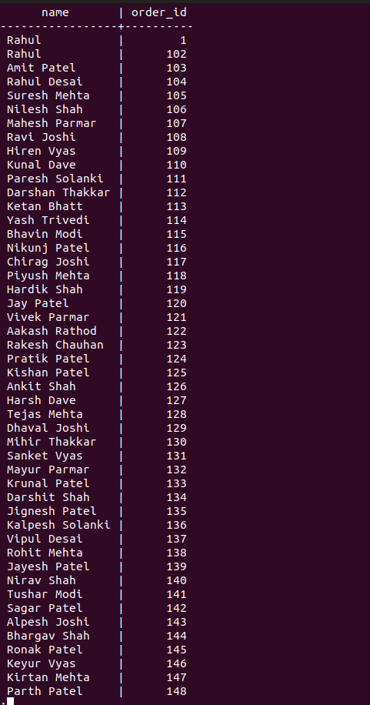

RIGHT JOIN
SELECT u.name, o.order_id FROM users u RIGHT JOIN orders o ON u.user_id = o.user_id;
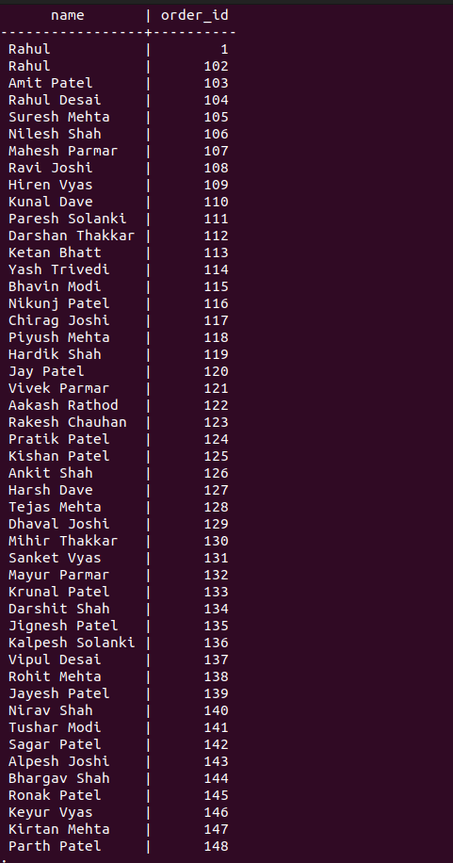

FULL JOIN
- SELECT u.name, o.order_id FROM users u FULL JOIN orders o ON u.user_id = o.user_id;

8. ER Diagram

The ER Diagram was generated using DBeaver DBUA, showing:
- Users connected to Orders
- Orders connected to Order Items
- Products linked to Order Items
- Payments linked to Orders
This diagram represents the database schema.

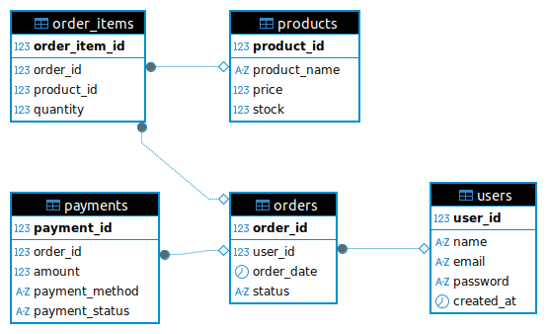

9. Conclusion

This project successfully demonstrates the design and implementation of a real-world E-Commerce Database System using PostgreSQL.
The system supports customer management, product management, order tracking, and payment processing with proper relational integrity.
Through SQL queries, joins, grouping, and ER diagrams, the database was validated and analyzed.
This project provides strong practical knowledge of relational databases and SQL used in modern e-commerce platforms.

